Lab 10-11
Nguyễn đức phát - 1150080152
Lớp: THMT
Truyện FANTASY
Bởi vì dự án em hơn 25MB nên không thể gửi lên github được nên sẽ để 1 đường dẫn đã nén file trên gg driver
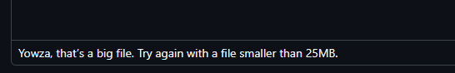
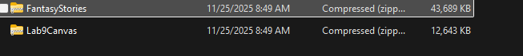
https://drive.google.com/file/d/1HowQh1AfyECx6mEVaoDG2cUWpVATH5-M/view?usp=drive_link
Dự án đặt tên là: FantasyStories
Hình ảnh kết quả:
- Giao diện khi vào app
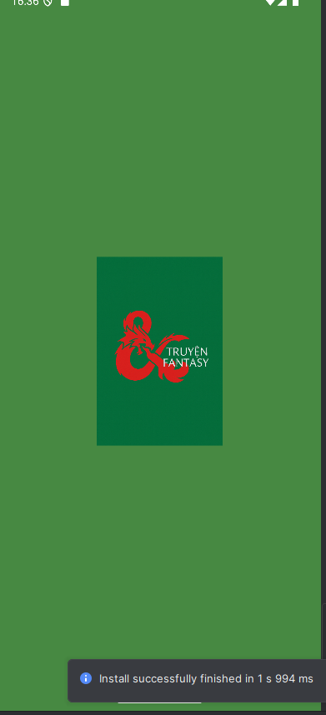
- Giao diện trang chủ
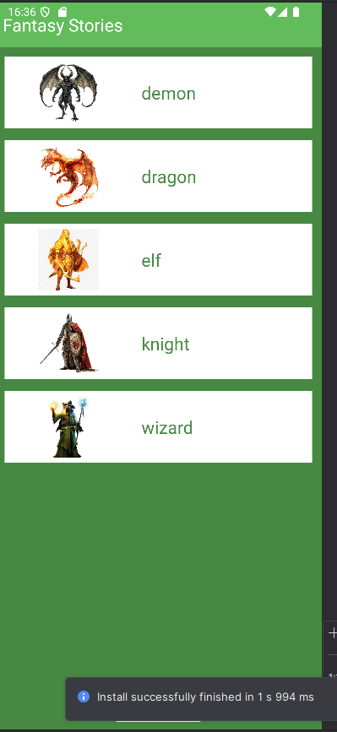
- Giao diện list truyện
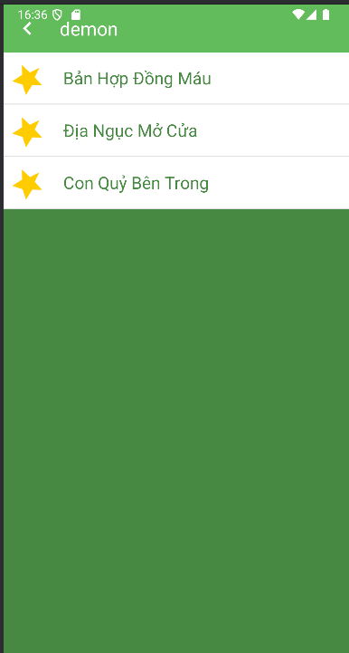
- Giao diện truyện


Các bước thực hiện:
Bước 1: Tạo project FantasyStories
Đặt tên project: FantasyStories
Bước 2: Tạo thư mục assets/story và assets/photo
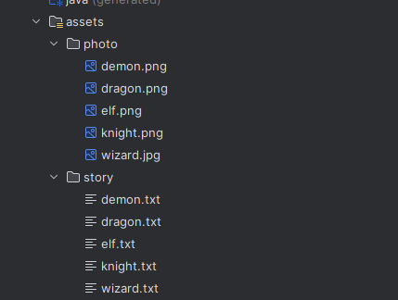
Bên cạnh đó thêm các ic và logo cho app:
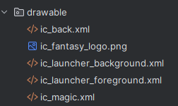
Bước 3: Tạo model StoryEntity
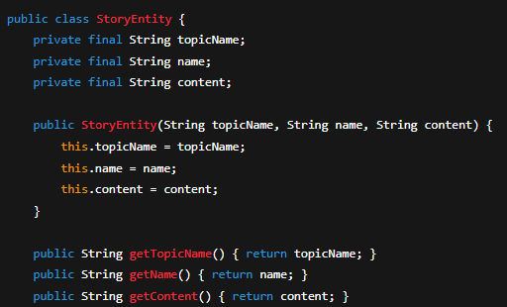

Bước 3: MainActivity điều hướng Fragment
package com.example.fantasystories;
import android.os.Bundle;
import androidx.appcompat.app.AppCompatActivity;
import androidx.fragment.app.Fragment;
public class MainActivity extends AppCompatActivity {
private String topicName;
@Override
protected void onCreate(Bundle savedInstanceState) {
super.onCreate(savedInstanceState);
setContentView(R.layout.activity_main);
showFrg(new M000SplashFrg());
}
private void showFrg(Fragment frg) {
getSupportFragmentManager()
.beginTransaction()
.replace(R.id.ln_main, frg, null)
.commit();
}
public void gotoM001Screen() {
showFrg(new M001TopicFrg());
}
public void gotoM002Screen(String topicName) {
this.topicName = topicName;
M002StoryFrg frg = new M002StoryFrg();
frg.setTopicName(topicName);
showFrg(frg);
}
public void gotoM003Screen(java.util.ArrayList<StoryEntity> listStory, StoryEntity story) {
M003DetailStoryFrg frg = new M003DetailStoryFrg();
frg.setData(topicName, listStory, story);
showFrg(frg);
}
public void backToM001Screen() {
gotoM001Screen();
}
}

Bước 4: Tạo màn Splash (M000)
Layout:
<?xml version="1.0" encoding="utf-8"?>
<FrameLayout xmlns:android="http://schemas.android.com/apk/res/android"
android:layout_width="match_parent"
android:layout_height="match_parent"
android:background="@color/greenMid">
<ImageView
android:layout_width="match_parent"
android:layout_height="250dp"
android:layout_gravity="center"
android:src="@drawable/ic_fantasy_logo"
android:scaleType="fitCenter"
android:adjustViewBounds="true"/>
</FrameLayout>

Fragment:
package com.example.fantasystories;
import android.os.Bundle;
import android.os.Handler;
import android.view.*;
import androidx.fragment.app.Fragment;
public class M000SplashFrg extends Fragment {
@Override
public View onCreateView(LayoutInflater inflater, ViewGroup container, Bundle savedInstanceState) {
initViews();
return inflater.inflate(R.layout.m000_frg_splash, container, false);
}
private void initViews() {
new Handler().postDelayed(this::gotoM001Screen, 2000);
}
private void gotoM001Screen() {
((MainActivity) getActivity()).gotoM001Screen();
}
}
Bước 5: Màn hình Topic (M001)
Layout:
<?xml version="1.0" encoding="utf-8"?>
<LinearLayout xmlns:android="http://schemas.android.com/apk/res/android"
android:layout_width="match_parent"
android:layout_height="match_parent"
android:orientation="vertical"
android:background="@color/greenMid">
<include layout="@layout/actionbar_home"/>
<ScrollView
android:layout_width="match_parent"
android:layout_height="match_parent">
<LinearLayout
android:id="@+id/ln_topic"
android:layout_width="match_parent"
android:layout_height="wrap_content"
android:orientation="vertical"
android:padding="12dp"/>
</ScrollView>
</LinearLayout>
Item topic:
<?xml version="1.0" encoding="utf-8"?>
<LinearLayout xmlns:android="http://schemas.android.com/apk/res/android"
android:layout_width="match_parent"
android:layout_height="wrap_content"
android:orientation="horizontal"
android:layout_marginBottom="12dp"
android:background="@color/white">
<ImageView
android:id="@+id/iv_topic"
android:layout_width="160dp"
android:layout_height="90dp"
android:padding="6dp"
android:src="@drawable/ic_magic"/>
<TextView
android:id="@+id/tv_topic"
android:layout_width="match_parent"
android:layout_height="match_parent"
android:text="Dragon"
android:textColor="@color/greenMid"
android:textSize="22sp"
android:gravity="center_vertical"
android:paddingStart="12dp"/>
</LinearLayout>
Fragment:
package com.example.fantasystories;
import android.content.Context;
import android.graphics.BitmapFactory;
import android.os.Bundle;
import android.view.*;
import android.widget.*;
import androidx.fragment.app.Fragment;
public class M001TopicFrg extends Fragment implements View.OnClickListener {
private Context mContext;
@Override
public View onCreateView(LayoutInflater inflater, ViewGroup container, Bundle savedInstanceState) {
View rootView = inflater.inflate(R.layout.m001_frg_topic, container, false);
initViews(rootView);
return rootView;
}
@Override
public void onAttach(Context context) {
super.onAttach(context);
mContext = context;
}
private void initViews(View v) {
LinearLayout lnMain = v.findViewById(R.id.ln_topic);
lnMain.removeAllViews();
try {
String[] listItem = mContext.getAssets().list("photo");
for (String fileName : listItem) {
String name = fileName.substring(0, fileName.indexOf("."));
View vTopic = LayoutInflater.from(mContext)
.inflate(R.layout.item_topic, null);
ImageView ivTopic = vTopic.findViewById(R.id.iv_topic);
TextView tvTopic = vTopic.findViewById(R.id.tv_topic);
ivTopic.setImageBitmap(BitmapFactory.decodeStream(
mContext.getAssets().open("photo/" + fileName)));
tvTopic.setText(name);
lnMain.addView(vTopic);
LinearLayout.LayoutParams params =
(LinearLayout.LayoutParams) vTopic.getLayoutParams();
params.bottomMargin = 40;
vTopic.setLayoutParams(params);
vTopic.setTag(name);
vTopic.setOnClickListener(this);
}
} catch (Exception e) {
e.printStackTrace();
}
}
@Override
public void onClick(View v) {
((MainActivity) getActivity()).gotoM002Screen((String) v.getTag());
}
}
Bước 6: Màn hình danh sách truyện (M002)
Layout:
<?xml version="1.0" encoding="utf-8"?>
<LinearLayout xmlns:android="http://schemas.android.com/apk/res/android"
android:layout_width="match_parent"
android:layout_height="match_parent"
android:orientation="vertical"
android:background="@color/greenMid">
<include layout="@layout/actionbar_home"/>
<androidx.recyclerview.widget.RecyclerView
android:id="@+id/rv_story"
android:layout_width="match_parent"
android:layout_height="match_parent"/>
</LinearLayout>
Adapter: StoryAdapter
package com.example.fantasystories;
import android.content.Context;
import android.view.*;
import android.widget.TextView;
import androidx.recyclerview.widget.RecyclerView;
import java.util.ArrayList;
public class StoryAdapter extends RecyclerView.Adapter<StoryAdapter.StoryHolder> {
private final ArrayList<StoryEntity> listStory;
private final Context mContext;
public StoryAdapter(ArrayList<StoryEntity> listStory, Context mContext) {
this.listStory = listStory;
this.mContext = mContext;
}
@Override
public StoryHolder onCreateViewHolder(ViewGroup parent, int viewType) {
View view = LayoutInflater.from(mContext)
.inflate(R.layout.item_story, parent, false);
return new StoryHolder(view);
}
@Override
public void onBindViewHolder(StoryHolder holder, int position) {
StoryEntity item = listStory.get(position);
holder.tvName.setTag(item);
holder.tvName.setText(item.getName());
}
@Override
public int getItemCount() {
return listStory.size();
}
public class StoryHolder extends RecyclerView.ViewHolder {
TextView tvName;
public StoryHolder(View itemView) {
super(itemView);
tvName = itemView.findViewById(R.id.tv_story);
itemView.setOnClickListener(v -> {
((MainActivity) mContext).gotoM003Screen(listStory,
(StoryEntity) tvName.getTag());
});
}
}
}
Fragment:
package com.example.fantasystories;
import android.content.Context;
import android.os.Bundle;
import android.view.*;
import android.widget.TextView;
import androidx.fragment.app.Fragment;
import androidx.recyclerview.widget.*;
import java.io.*;
import java.util.ArrayList;
public class M002StoryFrg extends Fragment {
private Context mContext;
private String topicName;
@Override
public View onCreateView(LayoutInflater inflater, ViewGroup container, Bundle savedInstanceState) {
View rootView = inflater.inflate(R.layout.m002_frg_story, container, false);
initViews(rootView);
return rootView;
}
@Override
public void onAttach(Context context) {
super.onAttach(context);
mContext = context;
}
private void initViews(View v) {
v.findViewById(R.id.iv_back).setVisibility(View.VISIBLE);
v.findViewById(R.id.iv_back).setOnClickListener(v1 -> backToM001Screen());
((TextView) v.findViewById(R.id.tv_name)).setText(topicName);
RecyclerView rv = v.findViewById(R.id.rv_story);
ArrayList<StoryEntity> listStory = readStory();
StoryAdapter adapter = new StoryAdapter(listStory, mContext);
rv.setAdapter(adapter);
rv.setLayoutManager(new LinearLayoutManager(mContext));
}
private ArrayList<StoryEntity> readStory() {
ArrayList<StoryEntity> listStory = new ArrayList<>();
BufferedReader reader;
try {
reader = new BufferedReader(new InputStreamReader(
mContext.getAssets().open("story/" + topicName + ".txt"), "UTF-8"));
String mLine = "";
do {
String title = reader.readLine();
if (title == null) break;
String content = "";
do {
mLine = reader.readLine();
content += mLine + "\n";
} while (!mLine.contains("','0');"));
content = content.replace("','0');", "");
listStory.add(new StoryEntity(topicName, title, content));
} while (mLine != null);
} catch (IOException e) {
e.printStackTrace();
}
return listStory;
}
public void setTopicName(String topicName) {
this.topicName = topicName;
}
private void backToM001Screen() {
((MainActivity) getActivity()).backToM001Screen();
}
}
Bước 7: Màn hình đọc truyện chi tiết (M003)
Layout:
<?xml version="1.0" encoding="utf-8"?>
<LinearLayout xmlns:android="http://schemas.android.com/apk/res/android"
android:layout_width="match_parent"
android:layout_height="match_parent"
android:orientation="vertical"
android:background="@color/white">
<include layout="@layout/actionbar_home"/>
<androidx.viewpager.widget.ViewPager
android:id="@+id/vp_story"
android:layout_width="match_parent"
android:layout_height="match_parent"/>
</LinearLayout>

Adapter:
package com.example.fantasystories;
import android.content.Context;
import android.view.*;
import android.widget.TextView;
import androidx.viewpager.widget.PagerAdapter;
import java.util.List;
public class DetailStoryAdapter extends PagerAdapter {
private final List<StoryEntity> listStory;
private final Context mContext;
public DetailStoryAdapter(List<StoryEntity> listStory, Context mContext) {
this.listStory = listStory;
this.mContext = mContext;
}
@Override
public Object instantiateItem(ViewGroup container, int position) {
View view = LayoutInflater.from(mContext)
.inflate(R.layout.item_detail_story, container, false);
StoryEntity item = listStory.get(position);
TextView tvName = view.findViewById(R.id.tv_name);
TextView tvContent = view.findViewById(R.id.tv_content);
tvName.setText(item.getName());
tvContent.setText(item.getContent());
container.addView(view);
return view;
}
@Override
public int getCount() {
return listStory.size();
}
@Override
public boolean isViewFromObject(View view, Object object) {
return view.equals(object);
}
@Override
public void destroyItem(ViewGroup container, int position, Object object) {
container.removeView((View) object);
}
}

Fragment:
package com.example.fantasystories;
import android.content.Context;
import android.os.Bundle;
import android.view.*;
import android.widget.TextView;
import androidx.fragment.app.Fragment;
import androidx.viewpager.widget.ViewPager;
import java.util.ArrayList;
public class M003DetailStoryFrg extends Fragment {
private Context mContext;
private ArrayList<StoryEntity> listStory;
private String topicName;
private StoryEntity currentStory;
@Override
public View onCreateView(LayoutInflater inflater, ViewGroup container, Bundle savedInstanceState) {
View rootView = inflater.inflate(R.layout.m003_frg_detail_story, container, false);
initViews(rootView);
return rootView;
}
@Override
public void onAttach(Context context) {
super.onAttach(context);
mContext = context;
}
private void initViews(View v) {
v.findViewById(R.id.iv_back).setVisibility(View.VISIBLE);
v.findViewById(R.id.iv_back).setOnClickListener(v1 -> backToM002Screen());
((TextView) v.findViewById(R.id.tv_name)).setText(topicName);
ViewPager vp = v.findViewById(R.id.vp_story);
DetailStoryAdapter adapter = new DetailStoryAdapter(listStory, mContext);
vp.setAdapter(adapter);
vp.setCurrentItem(listStory.indexOf(currentStory), true);
}
private void backToM002Screen() {
((MainActivity) getActivity()).gotoM002Screen(topicName);
}
public void setData(String topic, ArrayList<StoryEntity> list, StoryEntity story) {
topicName = topic;
listStory = list;
currentStory = story;
}
}
item_story
<?xml version="1.0" encoding="utf-8"?>
<LinearLayout xmlns:android="http://schemas.android.com/apk/res/android"
android:layout_width="match_parent"
android:layout_height="wrap_content"
android:orientation="vertical"
android:background="@color/white">
<TableRow
android:layout_width="match_parent"
android:layout_height="wrap_content">
<ImageView
android:layout_width="60dp"
android:layout_height="60dp"
android:src="@drawable/ic_magic"
android:padding="10dp"
android:rotation="45"/>
<TextView
android:id="@+id/tv_story"
android:layout_width="match_parent"
android:layout_height="match_parent"
android:padding="10dp"
android:text="Tên truyện"
android:textColor="@color/greenMid"
android:textSize="20sp"
android:gravity="center_vertical"/>
</TableRow>
<View
android:layout_width="match_parent"
android:layout_height="1dp"
android:background="#e0e0e0"/>
</LinearLayout>

